Linux Commands Assignment

1. Creating and Renaming Files/Directories
Command:
mkdir test_dir
cd test_dir
touch example.txt
mv example.txt renamed_example.txt
Explanation:
- mkdir creates a new directory.
- cd moves into that directory.
- touch creates an empty file.
- mv renames or moves files.

2. Viewing File Contents
Command:
cat /etc/passwd
head -n 5 /etc/passwd
tail -n 5 /etc/passwd
Explanation:
- cat displays full file content.
- head shows first 5 lines.
- tail shows last 5 lines.
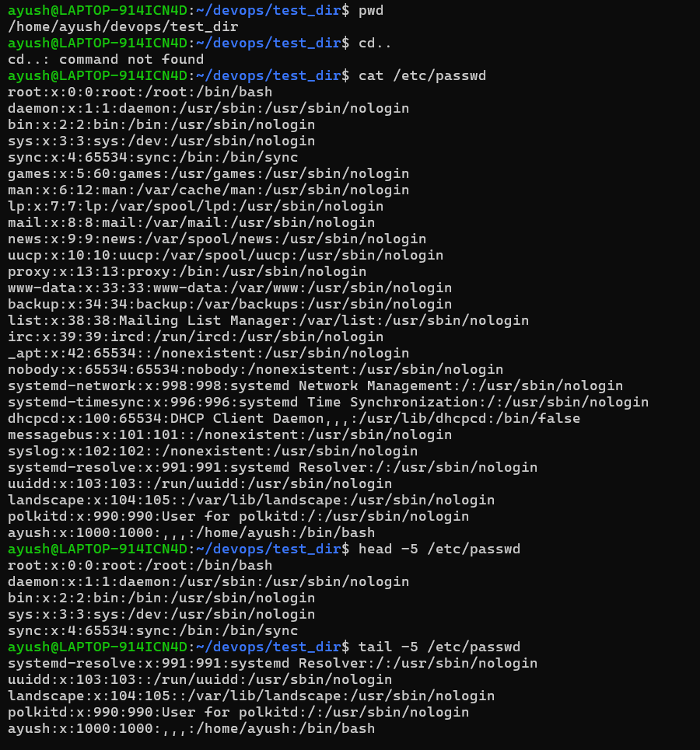

3. Searching for Patterns
Command:
grep "root" /etc/passwd
Explanation:
- grep searches for lines containing the word 'root'.

4. Zipping and Unzipping
Command:
zip -r test_dir.zip test_dir
unzip test_dir.zip -d unzipped_dir
Explanation:
- zip compresses the directory.
- unzip extracts it into a new directory.

5. Downloading Files
Command:
wget https://example.com/sample.txt
Explanation:
- wget downloads a file from a URL.
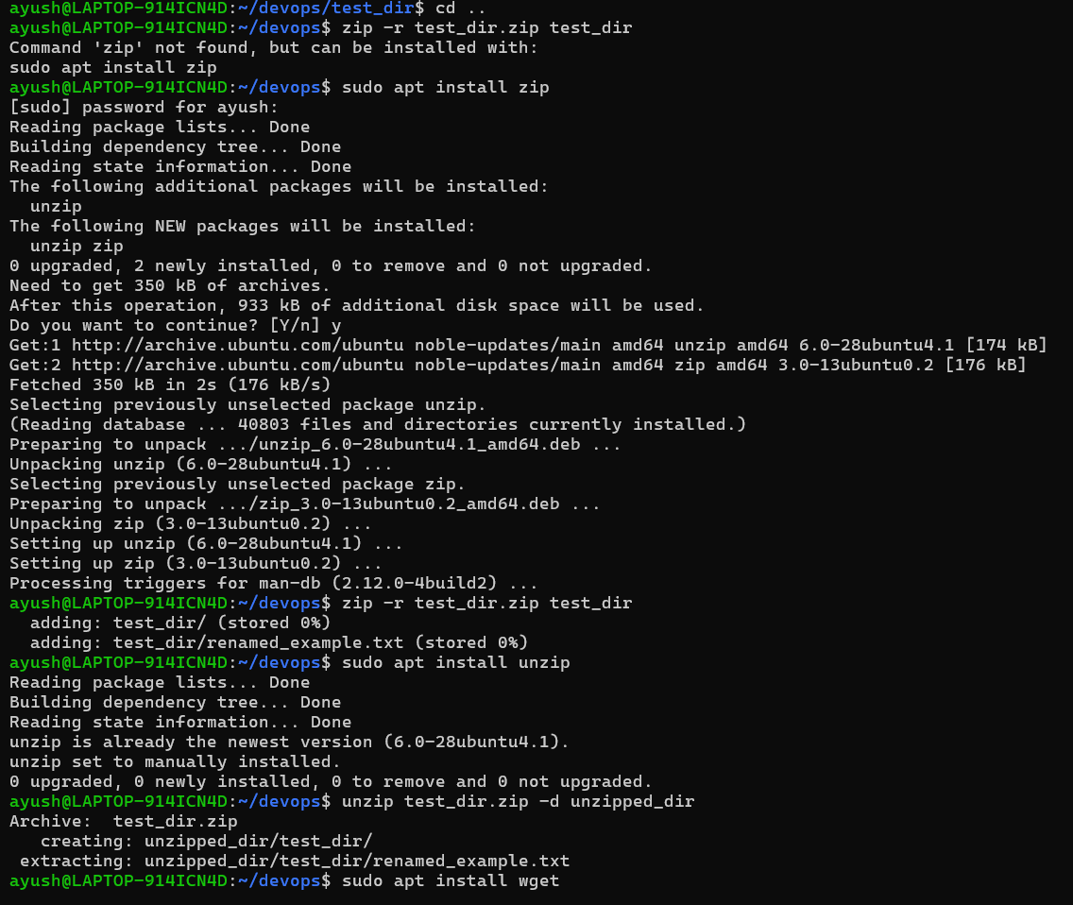
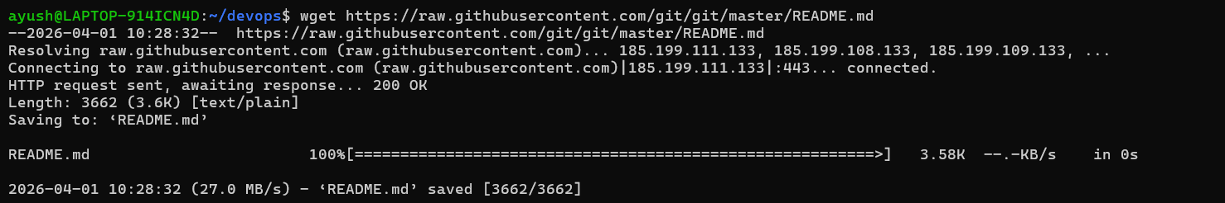

6. Changing Permissions
Command:
touch secure.txt
chmod 444 secure.txt
Explanation:
- chmod 444 makes the file read-only for everyone.
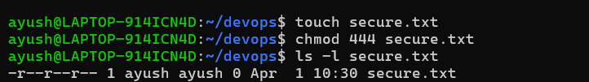

7. Working with Environment Variables
Command:
export MY_VAR="Hello, Linux!"
Explanation:
- export creates an environment variable with a value.


